

**Search Engine Optimization**

**SUBMITTED TO :**

#### Mr.Rao Shabaz Qadeer

**SUBMITTED BY :**

**SYEDA WAJEEHA FARHAT BBIT-2021-112**



**UNIVERSITY OF ENGINEERING AND TECHNOLOGY, LAHORE.**

**Introduction of Cake zone website and 3 min video**

Cake Zone Bakery offers a variety of delicious creations to fit any celebration or taste since we think that every occasion deserves a little sweetness. Our talented pastry chefs and bakers put out endless effort to produce confections that surpass our clients' expectations, from sophisticated wedding cakes and fanciful birthday creations to luscious pastries and gourmet desserts.

Meta Tag Optimization: Include important keywords and a captivating description of Cake Zone Bakery's offerings in the title tag and meta description of all your meta tags. Increased click-through rates from search engine results pages (SERPs) arise from this.   
Mobile Optimization: As mobile responsiveness plays a major role in search engine rankings, make sure your website is optimized for mobile devices. In order to offer a seamless user experience, this involves optimizing the information, pictures, and design of websites for mobile devices.   
Superior Content: Produce top-notch, captivating content that adds value for users and motivates them to stay on the website longer. This can include blog entries, recipes, client endorsements, and behind-the-scenes films highlighting the skills and imagination of Cake Zone Bakery.   
Building Backlinks: Create backlinks from respectable websites in the baking and food industries, as well as

Keyword Optimization: Use pertinent keywords like "custom cakes," "wedding cakes," "birthday cakes," and "gourmet desserts" throughout the text. Incorporate these keywords organically into the content to increase search engine visibility.   
Local SEO: Use keywords that are specific to your area to attract clients. For example, include the city or neighborhood where Cake Zone Bakery is situated. This increases visibility for people looking for local bakery services.  
The Cake Zone Bakery's unique selling proposition (USP) should be highlighted. Some of these include "custom creations," "quality ingredients," "attention to detail," and "personalized service." These words and phrases can help the bakery stand out from rival establishments and draw in new clients.

Cake Zone Bakery takes great satisfaction in its ability to craft confections that are specifically customized to meet the individual needs and tastes of each client. Our skilled staff will collaborate closely with you to realize your vision, whether it's a playful unicorn cake for a birthday celebration or a sophisticated tiered cake for a wedding.   
Excellent Ingredients: We think that using ingredients of the highest caliber is essential to creating sweets that truly shine. For this reason, we only use the best, freshest ingredients in our cakes and pastries to make sure that every mouthful is rich and decadent.   
Paying Close Attention to Details: We carefully consider every little detail in every one of our masterpieces, from delicate sugar flowers to hand-piped patterns. Personalized Service: Every client will receive personalized attention from our hardworking staff. We'll work closely with you to understand your needs and tastes, whether you're organizing a large-scale event or a small, private get-together. This will guarantee that your dessert fantasies come true.

The information about the schema markup is shown below in paragraph form:   
  
  
  
Schema markup is used by Cake Zone Bakery, a well-liked business known for its delicious pastries, to improve its internet visibility. Cake Zone, a Bakery entity, gives search engines the information they need to understand it better. This guarantees simple access to its products and includes both its name, Cake Zone Bakery, and the URL of its website. A brief summary of the bakery's products highlights its dedication to providing mouthwatering treats that go above and beyond for patrons.  
  
  
In addition to augmenting its online presence, Cake Zone Bakery makes its physical address available, making it simple for nearby clients to find it. To ensure smooth communication, a phone number is also included for orders and inquiries. The hours of operation are specified in detail, making it easier for prospective guests to plan. Additionally, the price range

Honoring Life's Moments: We at Cake Zone Bakery recognize the value of honoring the unique occasions in life. Whatever the occasion—a birthday, wedding, anniversary, or anything else—we want to develop sweets that are not only mouthwatering to eat but also contribute to lifelong memories.  
Engagement with the Community: We take great pride in being involved in activities and programs that uplift and honor the individuals and locations that define our unique community.

**Product 1:**

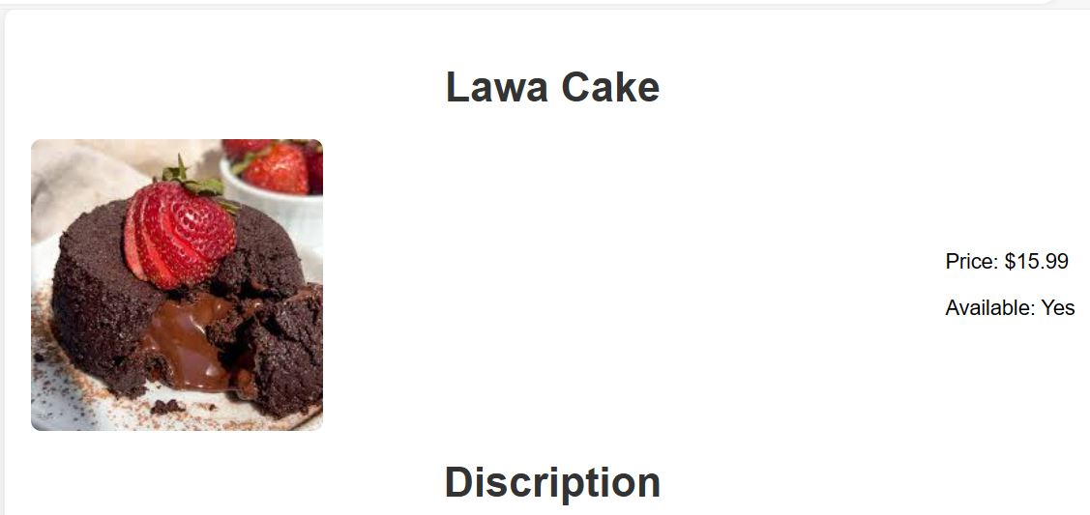

Australian culinary tradition, Lawa cakes are highly prized for their exquisite balance of flavors and textures. These delicious sweets, which date back to the late 1800s in Queensland, have grown to be adored as a representation of Australian resilience and inventiveness. With their ample coating of desiccated coconut and its soft sponge cake squares drowned in rich chocolate icing, Lamingtons are a delicious treat that combine sweetness, wetness, and crunch with each bite. Enjoyed at classic bake sales, sophisticated afternoon teas, or casual picnics, Lamington cakes remind Australians of warm, comforting memories of time spent with friends and family. The core of the Lamington, a timeless classic that never goes out of style and never fails to warm people's hearts across the Land, is unaffected by modifications.its complex layers and delicious flavors. With every decadent mouthful, the multifaceted profile of this traditional cake presents a symphony of sweet and salty elements. The Lawa cake looks like a visual feast at first, with layers upon layers of delectable flavors and textures. Usually, the bottom layer has a rich, buttery crust that gives the cake's other components a wonderfully balanced crunch. Above this is a rich layer of custardy goodness that has been flavored with aromatic coconut, giving the whole thing a tropical

**Product 2:**

**Starshine cake**

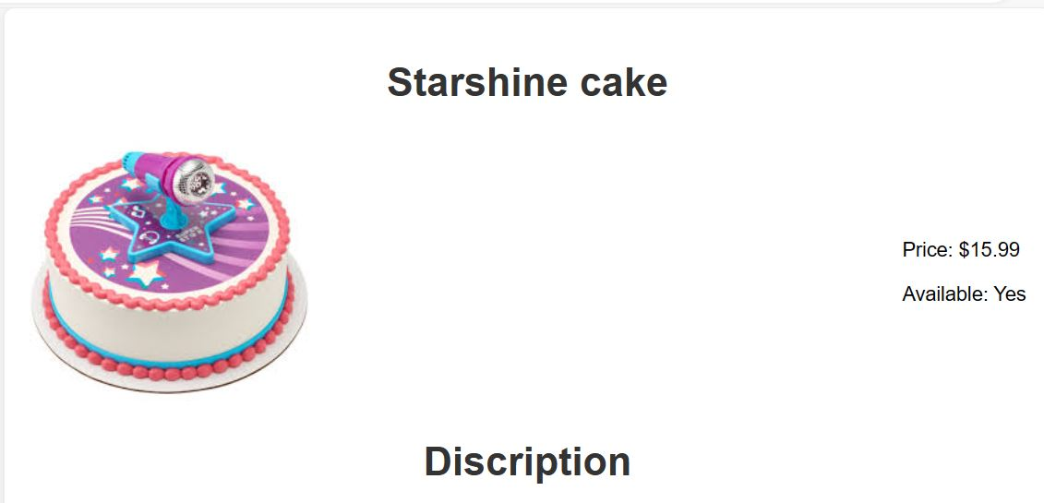

Starshine cakes are heavenly treats that infuse any event with a hint of mystery and magic. These charming candies, which have designs that shine and dazzle like stars, are modeled after the splendor and majesty of the night sky. A starshine cake catches the eye with its heavenly beauty right away. Decorated with edible glitter, glistening fondant accents, or elaborate motifs inspired by galaxies, these cakes convey the grandeur of space and take the observer to a realm of amazement and fascination. Beyond merely a dessert, the starshine cake is a representation of hopes and dreams, making it ideal for celebrating milestones like birthdays, graduations, or celebrations with a celestial theme. Its luminous presence brightens the space and lends a magical touch to any occasion, captivating guests and making them want to indulge in its heavenly appeal. Each starshine cake, whether it be decorated with glittering stars, whirling galaxies, or striking constellations, is a one-of-a-kind work of imagination and creativity that reflects the creator's distinct style and personality. The starshine cake is guaranteed to be the center of attention on any dessert table thanks to its heavenly beauty and enticing charm, which will make any occasion genuinely remarkable and unforgettable. Beyond merely a dessert, the starshine cake is a representation of hopes and dreams, making it ideal for celebrating milestones like birthdays, graduations, or celebrations with a celestial theme. Its luminous presence brightens the space and lends a magical touch to any occasion, captivating guests and making them want to indulge in its heavenly appeal.

**Product 3:**

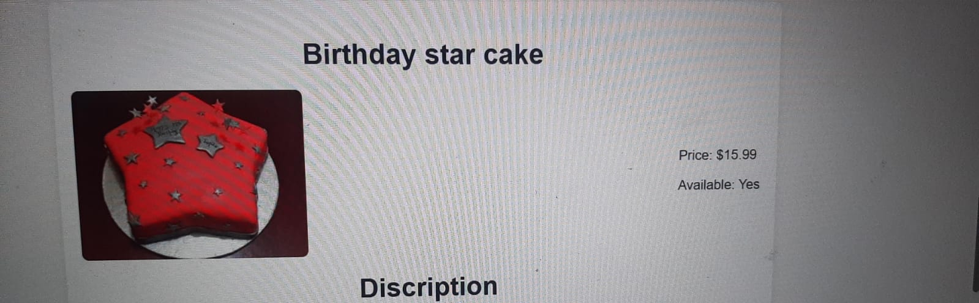

A delicious treat created to commemorate the special day of an exceptionally talented individual is the Birthday Star Cake. See a towering work of art, with every layer serving as a blank canvas for imagination and sweetness. The cake's sturdy base layer is usually a thick, moist layer that tastes like chocolate or vanilla. Moving above, you'll come across layers decorated with rich icing, possibly in colors that complement the celebration's celebratory theme. There may be hidden surprises between each layer, like as fluffy whipped cream, rich ganache, or fresh berries, giving each bite a taste and texture explosion.It is now time to discuss the aesthetics. The cake embodies the spirit of celebration and is a work of artistic adornment. Picture it covered in bright hues, maybe with fondant stars, glistening sprinkles, or edible glitter that twinkles like stars in the night sky. A stunning show awaits at the pinnacle of this edible artwork—possibly in the shape of a fondant figure or a personalized inscription proclaiming the recipient the day's real star.The Birthday Star Cake is essentially more than just a dessert; it's a work of art, lovingly created to make the birthday party genuinely remarkable.Let's now discuss the aesthetics. The cake is a work of artistic decorating that captures the spirit of the occasion. Imagine it covered in bright hues, maybe with stars made of fondant, sprinkles that shimmer, or edible glitter that glistens like stars in the night sky. to make the birthday party genuinely remarkable. There is a symphony of flavors waiting to be found as you cut through each layer. A layer could have undertones of caramel or espresso to entice the palate with a lovely richness. The exotic allure of tropical fruits like mango or passionfruit, or the tart sweetness of lemon, may reveal another dimension that catches you off guard. Every bite has more depth thanks to the interaction of textures between these layers. Picture a layer of silky custard that melts into every slice, or a decadent fruit compote that is brimming with the flavor of perfectly ripe peaches or berries. The careful selection of each element ensures that the flavors and textures are harmoniously balanced with one another.Let's now discuss the decoration. Both the eyes and the palate will be treated to a visual feast with the Birthday Star Cake. Imagine elaborate patterns carefully piped onto the surface, maybe a starry sky with shooting stars slicing across a midnight-blue fondant sky. A whimsical touch is added to the ensemble by the colorful edible flowers that cascade down the edges.

**Product 4:**

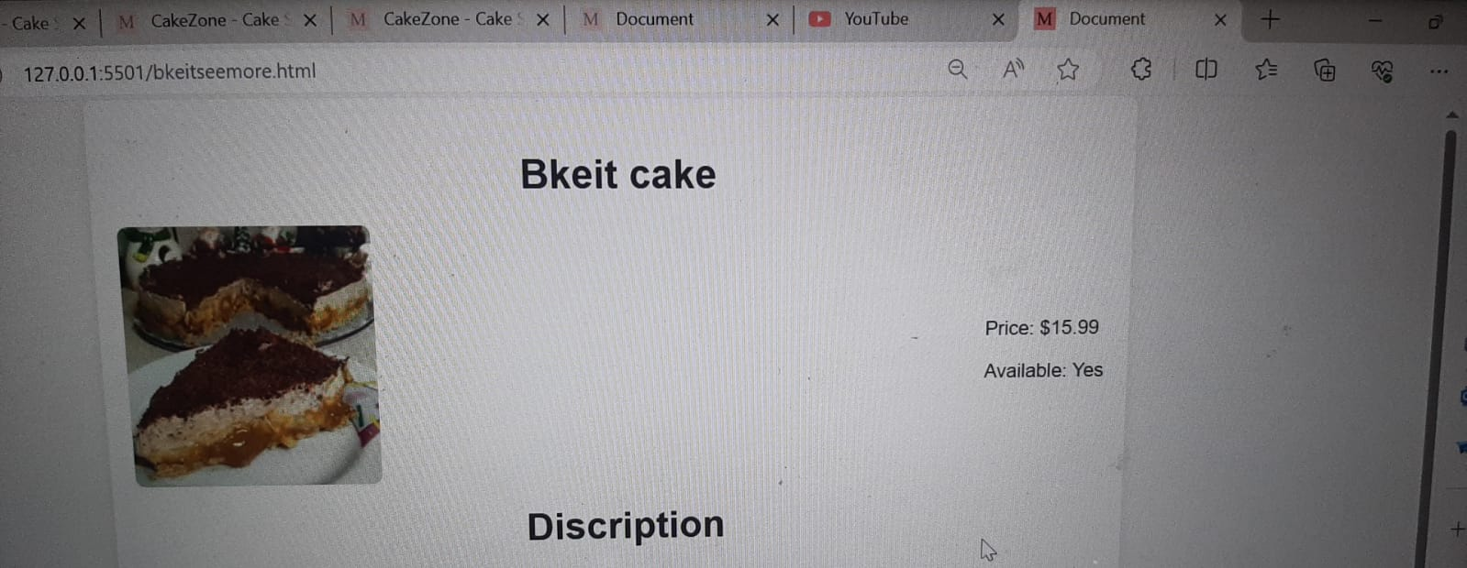

A "Bkeit" cake might be an original recipe, presumably derived from a particular geographical or cultural custom. Imagine a cake that is meant to please the senses and make people happy—a dessert that truly captures the spirit of celebration and indulgence. The "Bkeit" cake may have a visually arresting appearance with elaborate decorations or eye-catching colors that allude to the delicacies inside. It could be embellished with elaborate piping, edible flowers, or other decorations appropriate to the celebration.The flavor of the "Bkeit" cake might provide a mouthwatering blend of flavors and textures. It may have layers of soft sponge cake that have been flavored with exotic ingredients like rosewater, saffron, or cardamom to give it a unique and fragrant taste. Delish fillings like rich chocolate ganache, fragrant fruit compotes, or creamy custard may be sandwiched between these layers, giving each bite more nuance and richness. In order to add a pleasing crunch or contrast to the cake's soft inside, the "Bkeit" cake may be finished with a rich frosting or glaze that has been flavored with coconut, alIts aromatic profile might be enhanced with additional flavorings such as rose water, orange blossom water, or that has been passed down through the years, made with love and attention for special events like religious holidays, weddings, or festivals. Snacking on a piece of "Bkeit" cake with loved ones can be a welcoming and amicable gesture that strengthens ties and fosters connections. All things considered, a "Bkeit" cake is more than simply a treat; it's a culinary work of art that perfectly captures the intricate web of culture, custom, and skill. Its mouthwatering tastes, opulent textures, and cultural importance can satiate the senses and leave a lasting impression on everyone who indulges in it.

**Product 4:**

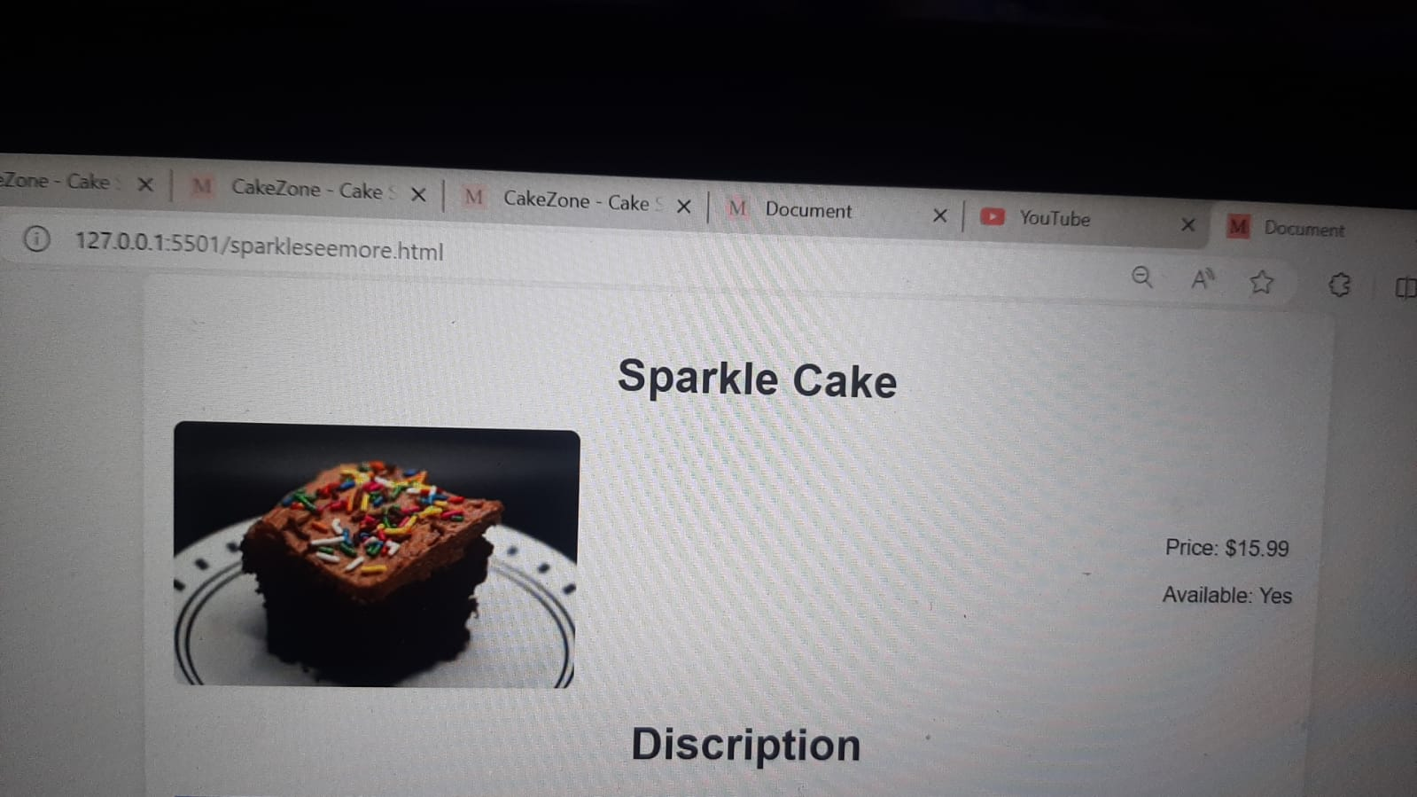

A sparkle cake is a visually stunning dessert that embodies happiness and celebration. This cake exudes a dazzling appeal that catches the eye and entices with its shimmering beauty.The glitter cake's lavish exterior catches the eye right away. This cake is glossy and sophisticated, adorned with edible glitter, sparkling pearls, or metallic accents. Carefully applied tiny details result in a captivating show that shimmers and shines in the light.Beyond just a dessert, the sparkling cake is a representation of joy and celebration that is ideal for marking important life events like anniversaries, birthdays, and weddings. Its bright presence fills the space with light and lends a magical touch to any occasion, A sparkle cake is a visually stunning dessert that embodies happiness and celebration. This cake exudes a dazzling appeal that catches the eye and entices with its shimmering beauty.The glitter cake's lavish exterior catches the eye right away. This cake is glossy and sophisticated, adorned with edible glitter, sparkling pearls, or metallic accents. Carefully applied tiny details result in a captivating show that shimmers and shines in the light.Beyond just a dessert, the sparkling cake is a to any occasions a one-of-a-kind work of art that reflects the creator's distinct style and personality. The glitter cake will undoubtedly be the centerpiece of any dessert table because to its glistening beauty and alluring appeal, which will make every moment genuinely sparkle and shine.

**Product 5**

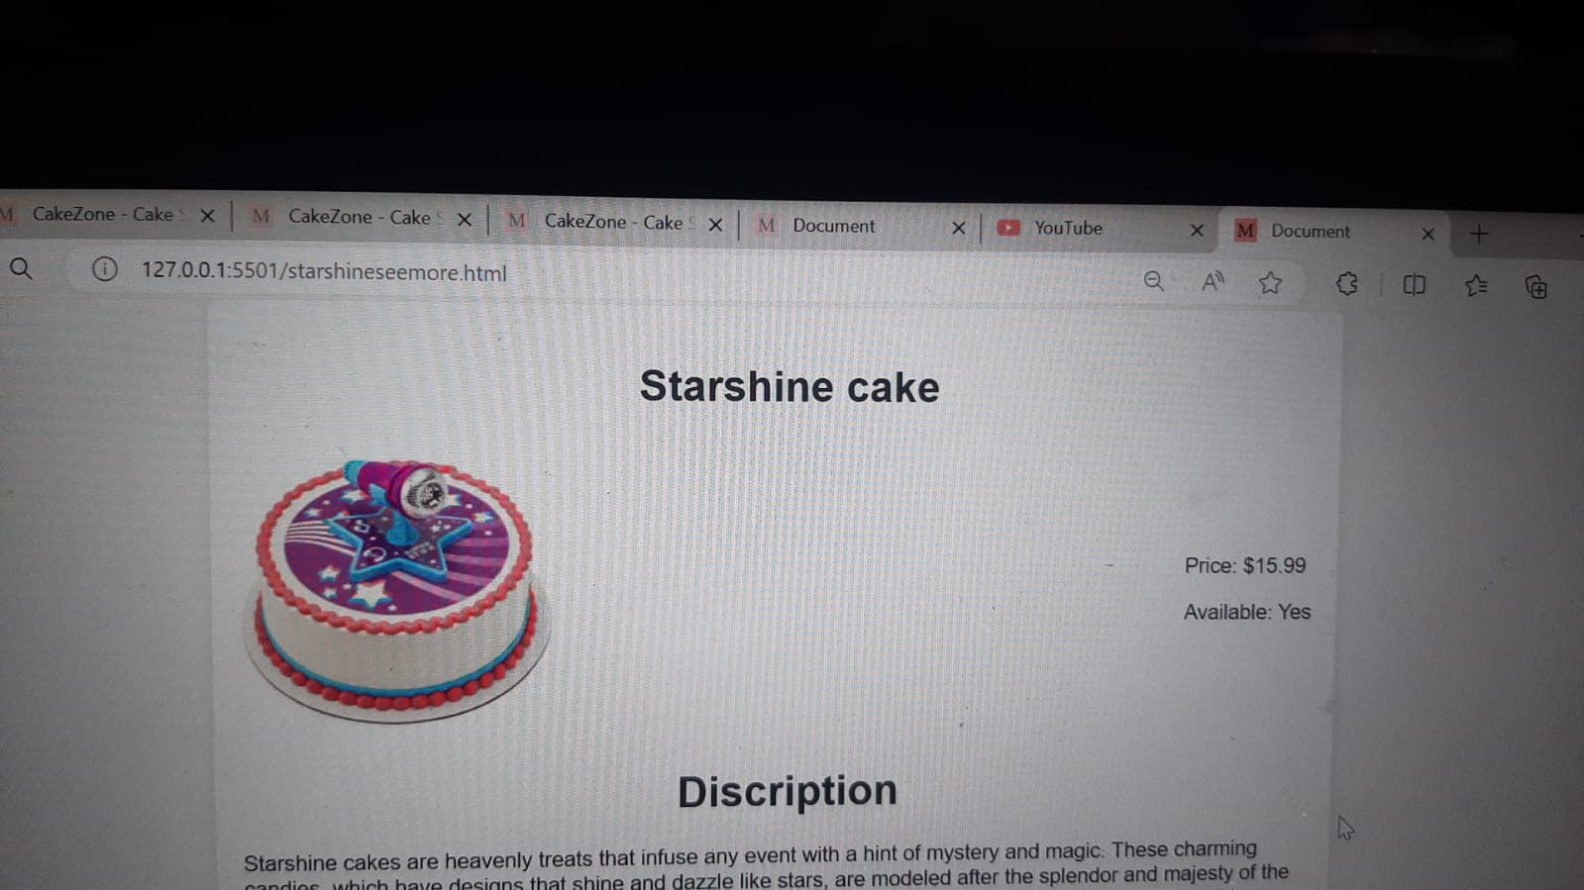

Starshine cakes are heavenly treats that infuse any event with a hint of mystery and magic. These charming candies, which have designs that shine and dazzle like stars, are modeled after the splendor and majesty of the night sky. A starshine cake catches the eye with its heavenly beauty right away. Decorated with edible glitter, glistening fondant accents, or elaborate motifs inspired by galaxies, these cakes convey the grandeur of space and take the observer to a realm of amazement and fascination. Beyond merely a dessert, the starshine cake is a representation of hopes and dreams, making it ideal for celebrating milestones like birthdays, graduations, or celebrations with a celestial theme. Its luminous presence brightens the space and lends a magical touch to any occasion, captivating guests and making them want to indulge in its heavenly appeal. Each starshine cake, whether it be decorated with glittering stars, whirling galaxies, or striking constellations, is a one-of-a-kind work of imagination and creativity that reflects the creator's distinct style and personality. The starshine cake is guaranteed to be the center of attention on any dessert table thanks to its heavenly beauty and enticing charm, which will make any occasion genuinely remarkable and unforgettable. Beyond merely a dessert, the starshine cake is a representation of hopes and dreams, making it ideal for celebrating milestones like birthdays, graduations, or celebrations with a celestial theme. Its luminous presence brightens the space and lends a magical touch to any occasion, captivating guests and making them want to indulge in its heavenly appeal.

**Product 6**

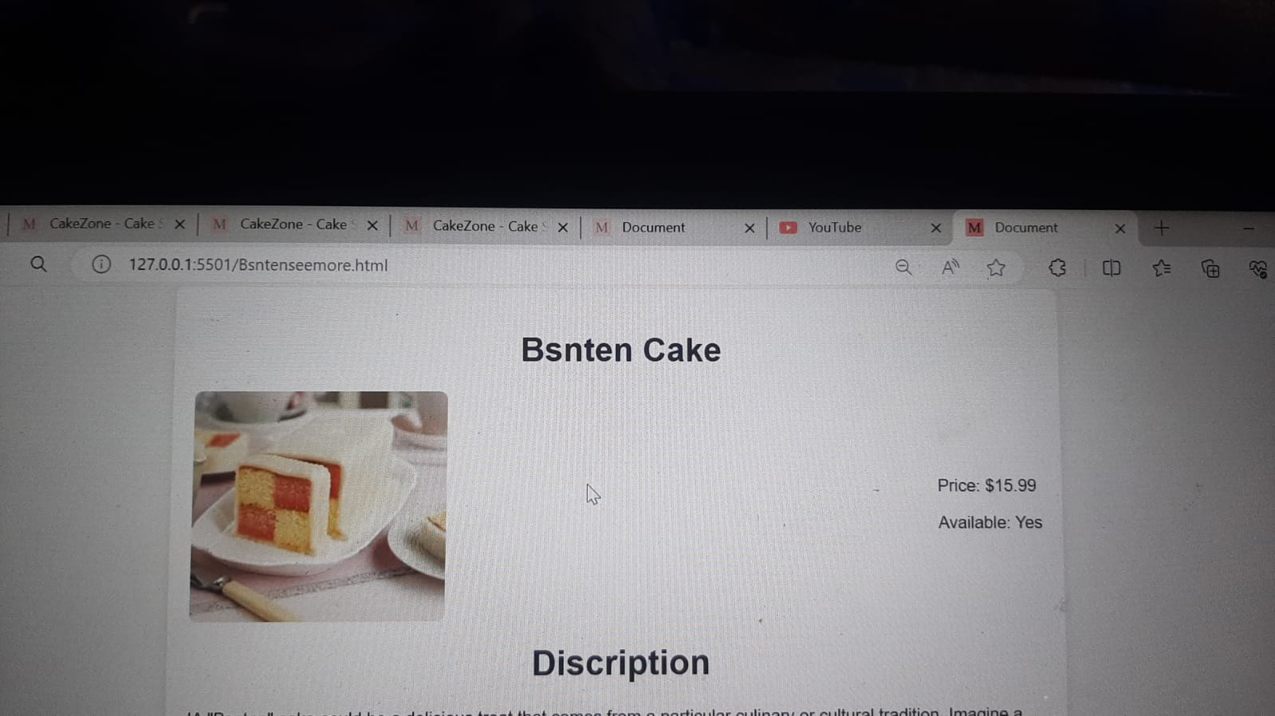

Bsnten" cake could be a delicious treat that comes from a particular culinary or cultural tradition. Imagine a cake that has been painstakingly and precisely designed to exhibit the ideal harmony of tastes, textures, and aesthetic appeal. The "Bsnten" cake's appearance could be a breathtaking work of art, with elaborate ornamentation or tasteful simplicity that grabs attention and distinguishes it from other desserts. It could be embellished with delectable flowers, elegant piping, or other decorations that fit the celebration's theme or occasion. cake became a favourite at Australian bake sales, afternoon teas, and picnics as it swiftly acquired popularity. Its simplicity belies its irresistible appeal, with each bite offering a symphony of sweetness and texture. Over the years, variations have emerged, with some incorporating jam or cream fillings, while others experiment with different coatings or flavors. Despite these adaptations, the essence of the Lamington remains true to its roots—a beloved symbol of Australian culinary tradition and ingenuity. The flavor of the "Bsnten" cake may be a pleasant blend of scents and tastes that have been thoughtfully selected to entice the senses and create a memorable memory. It could have layers of luscious cake flavored with rich chocolate, vanilla, or spice mixtures like nutmeg and cinnamon, giving it a flavor depth that changes with every bite. Rich fillings like smooth buttercream, tart fruit preserves, or decadent caramel may be sandwiched in between these layers to give the cake additional levels of texture and depth. A taste-bud-pleasing symphony of flavors would be produced by carefully choosing each component to enhance the others.

**Product 7**

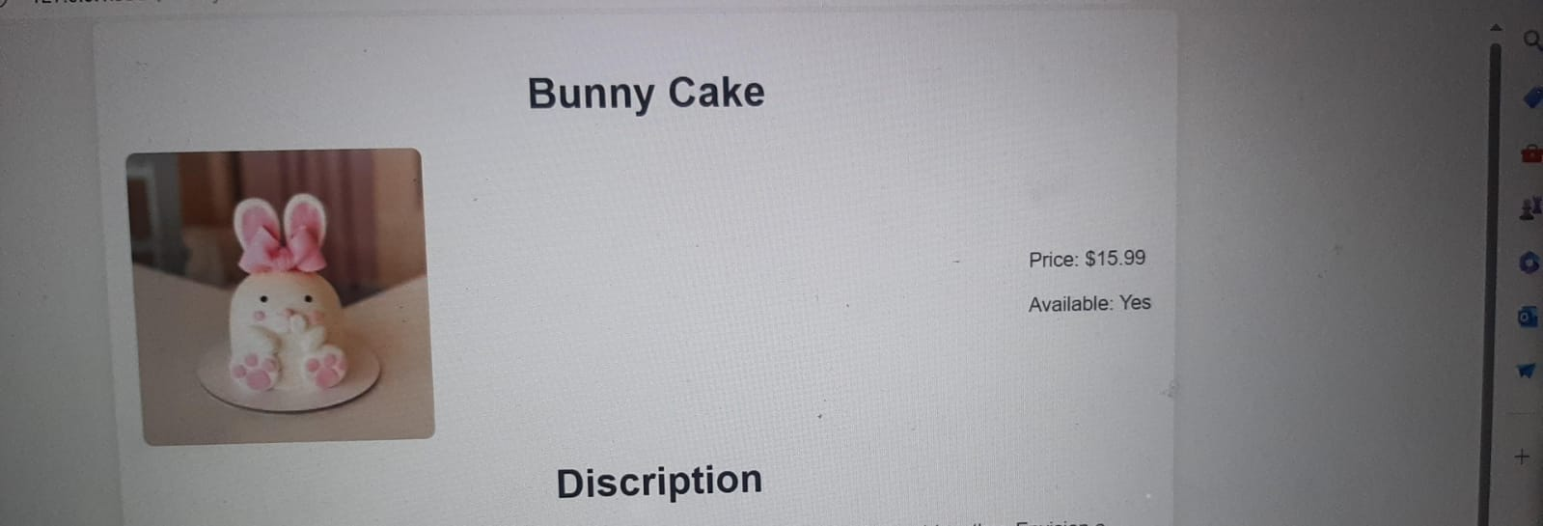

A cute and fun treat, rabbit cakes are ideal for Easter celebrations or any springtime get-together. Envision a cake fashioned like a cute rabbit, complete with fluffy frosting fur and endearing features that give it life. Layers of wonderful, moist cake, usually in flavors like chocolate or vanilla, form the base of a rabbit cake; but, because it's Easter, carrot cake is also a popular option. The form of a bunny is created by stacking and carving these layers, with one layer representing the body and another the head. Once the basic shape of a bunny has been achieved, a layer of smooth buttercream or cream cheese icing is applied to the cake to represent the fur of the bunny.Once the basic shape of a bunny has been achieved, a layer of smooth buttercream or cream cheese icing is applied to the cake to represent the fur of the bunny. To capture the essence of spring, you can dye the frosting with gentle pastel hues like lavender, blue, or pale pink. Extra embellishments are put to the bunny cake to give it personality. These might be jelly beans or chocolates covered in candy for the eyes, a tiny pink icing triangle for the nose, and piped frosting or crushed coconut for the whiskers. To finish the look, put a set of floppy ears to the bunny's head using fondant, marshmallows, or even cardboard covered in icing. Fur Texture: The bunny cake's frosting has a texture that mimics the fluffy fur of a rabbit, rather than just being smooth. Imagine delicate icing in the shape of gentle peaks or swirls covering the whole cake, giving it a tactile quality that enhances its allure. Expression on the Ears: The bunny's ears serve as the cake's main feature and may be designed in a variety of ways to represent different emotions. Imagine the bunny having long, floppy ears that hang down to the side, lending it a carefree, easygoing attitude. An alternative would be for the ears to stand straight, suggesting attention and inquiry. The bunny's overall appearance and charm are enhanced by the careful shaping and placement of each ear.

**Product 8**

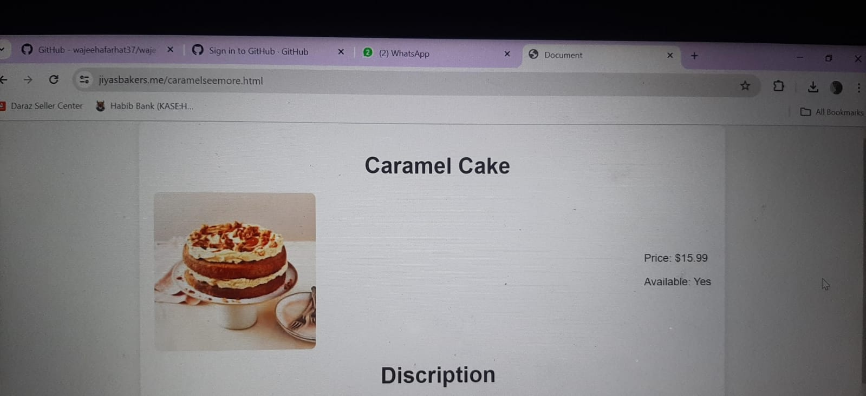

Indonesian caramel cake is a delicious treat that entices the senses with its distinct combination of flavours and textures. This classic cake, with its tiers of delectable sweet and savoury layers, is a masterwork of culinary craftsmanship.The lawa cake looks like a multi-layered extravaganza at first, with each layer having a unique flavour and texture. Usually, the bottom layer consists of a dense, buttery crust that gives each mouthful a delightful crunch. A layer of creamy custard flavoured with fragrant cocon sits above this.Deeper inside the cake, you find a layer of condensed milk that has been sweetened; this layer adds a luxurious smoothness that combines well with the other ingredients. Meanwhile, there are crispy toasted bits all over the cake.This simple cake became a favourite at Australian bake sales, afternoon teas, and picnics as it swiftly acquired popularity. Its simplicity belies its irresistible appeal, with each bite offering a symphony of sweetness and texture. Over the years, variations have emerged, with some incorporating jam or cream fillings, while others experiment with different coatings or flavors. Despite these adaptations, the essence of the Lamington remains true to its roots—a beloved symbol of Australian culinary tradition and ingenuity.

**Product 9**

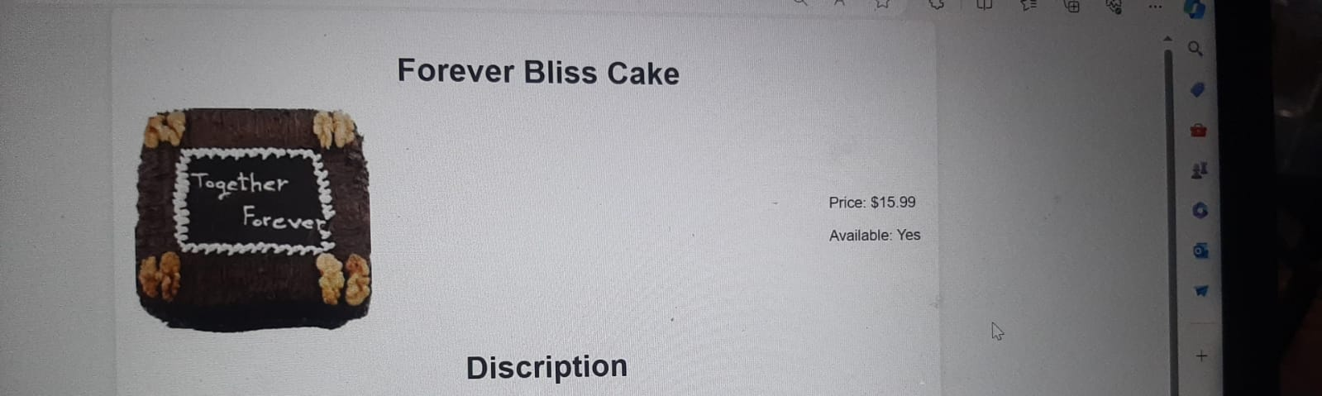

"Forever Bliss cakes" celebrate the unbreakable connection between two souls and radiate an aura of eternal bliss.

This simple cake became a favourite at Australian bake sales, afternoon teas, and picnics as it swiftly acquired popularity. Its simplicity belies its irresistible appeal, with each bite offering a symphony of sweetness and texture. Over the years, variations have emerged, with some incorporating jam or cream fillingsThis is an example of what might be on a Forever Bliss cake:Timeless Elegance: The elegant and timeless designs of Forever Bliss cakes symbolize the enduring quality of real love. These cakes frequently include tasteful tiers, subtle ornamentation, and crisp lines that convey sophistication and class. This simple cake became a favourite at Australian bake sales, afternoon teas, and picnics as it swiftly acquired popularity. Its simplicity belies its irresistible appeal, with each bite offering a symphony of sweetness and texture. Over the years, variations have emerged, with some incorporating jam or cream fillings, while others experiment with different coatings or flavors. Despite these adaptations, the essence of the Lamington remains true to its roots—a beloved symbol of Australian culinary tradition and ingenuity.

**Product 10**

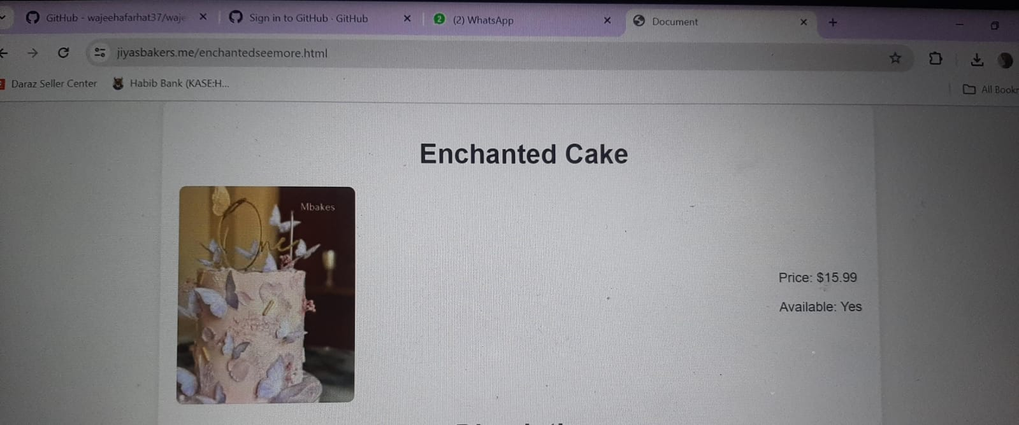

Union cakes represent the union of two people in a celebration of togetherness, love, and devotion. They frequently exude sophistication, grace, and ageless beauty. What might be included in a union cake is described as follows: Harmonious Design: Each tier of a union cake is covered in smooth fondant or icing, giving the cakes a classic, exquisite look. Simple yet symbolic components that depict the joining of two souls, such entwined hearts, infinity symbols, or a delicate lattice pattern signifying the fusing of two lives, may be used into the design. Traditional Elegance: These cakes frequently have a surite at Australian bake sales, afternoon teas, and picnics as it swiftly acquired popularity. Its simplicity belies its irresistible appeal, with each bite offering a symphony of sweetness and texture. Over the years, variations have emerged, with some incorporating jam or cream fillings, while others experiment with different coatings or flavors. Despite these adaptations, the essence of the Lamington remains true to its roots—a beloved symbol of Australian culinary tradition and ingenuity. Delicious Flavor Combinations: Beneath its elegant exterior, a union cake is often filled with delicious flavor combinations that delight the senses and leave a lasting impression on guests. Popular choices may include classic flavors like vanilla, chocolate, or red velvet, as well as more exotic options like lemon raspberry, tiramisu, or salted caramel. Overall, a union cake is more than just a dessert—it's a symbol of love, commitment, and partnership that serves as a centerpiece for the celebration of marriage. With its timeless elegance and personalized touches, it helps to create cherished memories that will last a lifetime.

**Product 11**

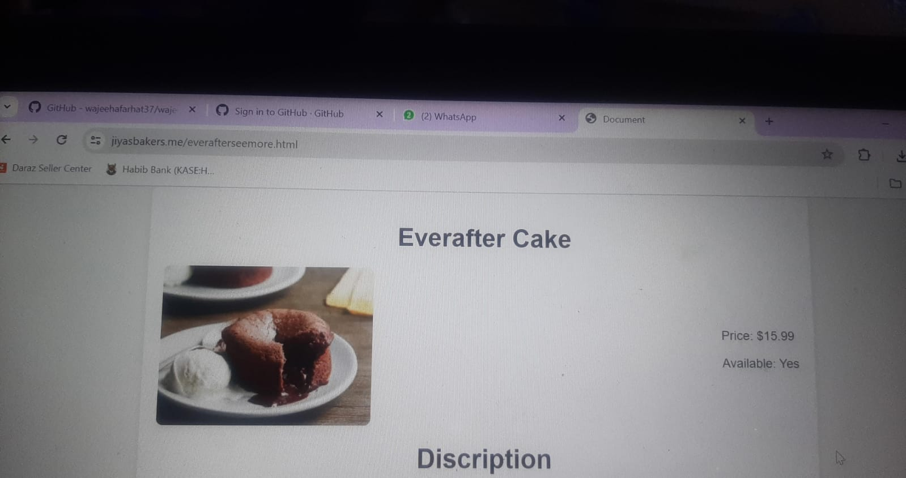

What may be included in an Everafter cake? Magical Design: Classic fairy tales and fantastical settings are frequently the source of inspiration for the quirky and entrancing designs that define Everafter cakes. These cakes could have decorations like tiny sugar flowers, elaborate lace designs, and fantasy themes like enchanted woodlands, fairytale castles, or mythical animals like dragons and unicorns. Dreamy Color Scheme: Everafter cakes usually have a soft, dreamy color scheme that heavily features pastel colors like blush pink, lavender, baby blue, and mint green. These soft hues arouse feelings of romance, purity, and wonder, transforming the space into a mystical place where guests are transported to by means of a fairy tale.Rich Flavors: An Everafter cake frequently has rich flavor combinations that entice the senses and create a lasting impact on guests, all beneath its charming surface. These luscious cakes come in a variety of flavors, from traditional ones like chocolate fudge and vanilla bean to more unusual ones like lavender honey and raspberry rose. They are both visually stunning and delicious. All things considered, an Everafter cake is more than simply a dessert; it's a wonderful piece of art that embodies the enchantment of a fairy tale and fills everyone who sees it with awe and delight. It makes the wedding celebration genuinely unforgettable by infusing it with a magical décor, unique touches, and delectable delicacies that make guests feel as though they've entered their own happily ever after.

**Product 12**

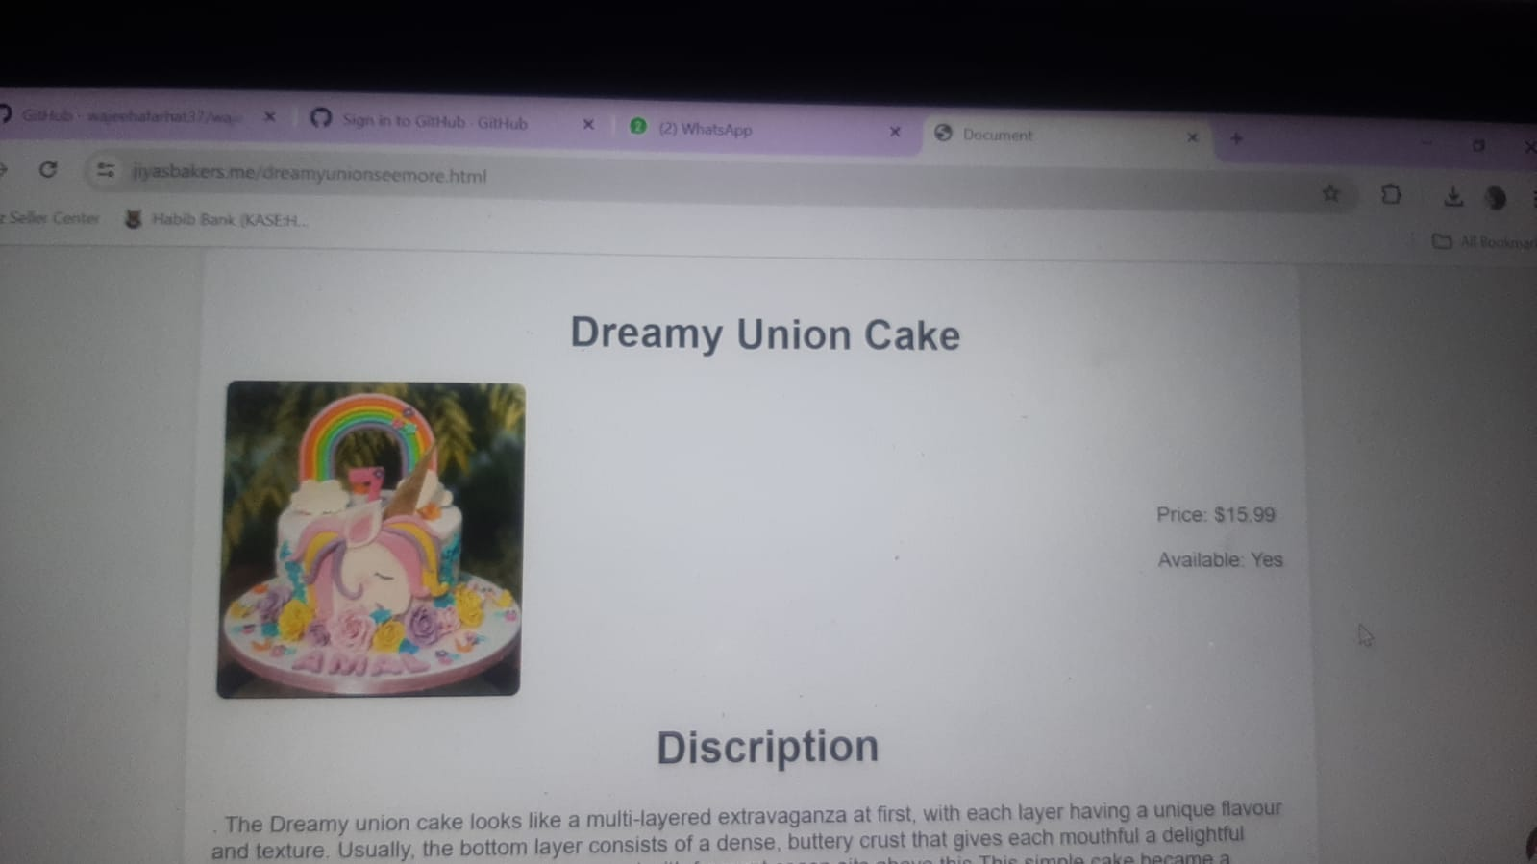

. The Dreamy union cake looks like a multi-layered extravaganza at first, with each layer having a unique flavour and texture. Usually, the bottom layer consists of a dense, buttery crust that gives each mouthful a delightful crunch. A layer of creamy custard flavoured with fragrant cocon sits above this.This simple cake became a favourite at Australian bake sales, afternoon teas, and picnics as it swiftly acquired popularity. Its simplicity belies its irresistible appeal, with each bite offering a symphony of sweetness and texture. Over the years, variations have emerged, with some incorporating jam or cream fillings, while others experiment with different coatings or flavors. Despite these adaptations, the essence of the Lamington remains true to its roots—a beloved symbol of Australian culinary tradition and ingenuity.Dreamy union cakes, created to commemorate the joining of two souls in love, are the pinnacle of elegance and romance. These cakes frequently have delicate embellishments and ethereal features that convey a feeling of enchantment and magic. This is an example of what could be included in a dreamlike union cake: Layers of Love: Usually consisting of multiple layers, the cake symbolizes the couple's layers of dedication and love. Every tier is painstakingly adorned to go in with the wedding's general theme and style.

**Product 13**

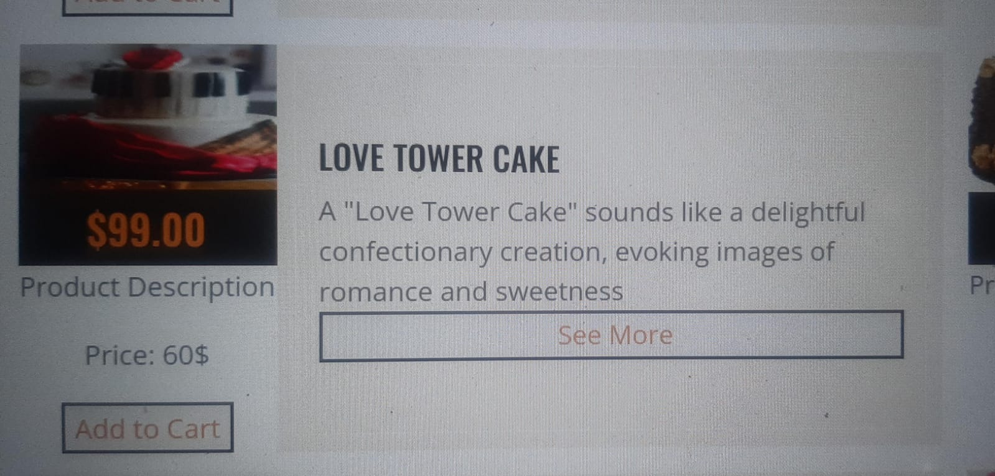

A magnificent confection, the Love Tower cake is a representation of celebration and romance. This cake, standing tall and strong, exudes the grandeur and elegance appropriate for a momentous occasion celebrating love and commitment.The Love Tower cake is composed of several layers, each expertly made to perfection. These layers, which frequently differ in size and form, provide an aesthetically magnificent work of art that attracts attention and admiration.A symphony of flavors and textures that entice the taste senses and create a memorable impression greets one as they explore deeper into the layers of the Love Tower cake. With tastes ranging from traditional favorites like smooth chocolate and rich vanilla to more unusual pairings like tart lemon and spicy raspberry, every level provides a distinct gastronomic encounter that satisfies the palate.Rich fillings including rich buttercream, smooth ganache, and juicy preserves give every bite of the rich cake layers a rush of taste and decadence. Every filling enhances the overall flavor profile of the Love Tower cake, whether it's the crisp lemon curd or the velvety embrace of silken caramel.

**Product 14**

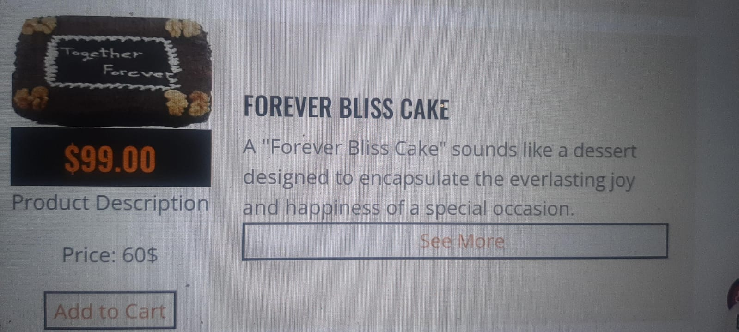

"Forever Bliss cakes" celebrate the unbreakable connection between two souls and radiate an aura of eternal bliss. This is an example of what might be on a Forever Bliss cake:Timeless Elegance: The elegant and timeless designs of Forever Bliss cakes symbolize the enduring quality of real love. These cakes frequently include tasteful tiers, subtle ornamentation, and crisp lines that convey sophistication and class. This simple cake became a favourite at Australian bake sales, afternoon teas, and picnics as it swiftly acquired popularity. Its simplicity belies its irresistible appeal, with each bite offering a symphony of sweetness and texture. Over the years, variations have emerged, with some incorporating jam or cream fillings, while others experiment with different coatings or flavors. Despite these adaptations, the essence of the Lamington remains true to its roots—a beloved symbol of Australian culinary tradition and ingenuity.

**Product 15**

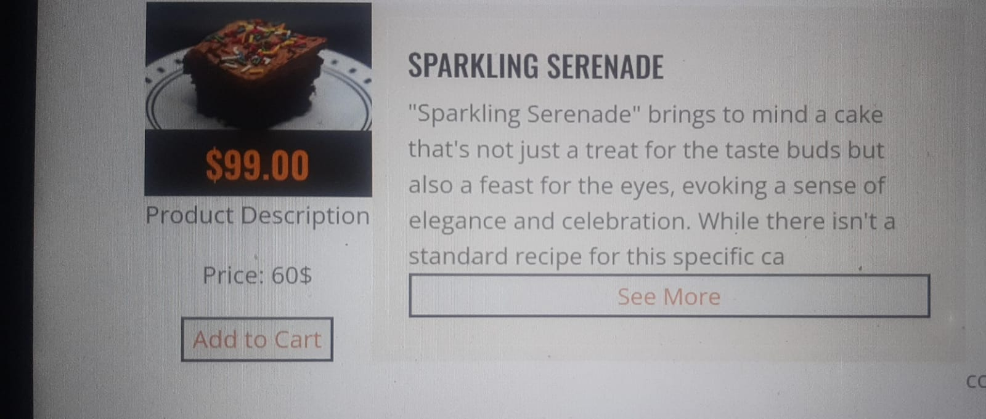

A sparkle cake is a visually stunning dessert that embodies happiness and celebration. This cake exudes a dazzling appeal that catches the eye and entices with its shimmering beauty.The glitter cake's lavish exterior catches the eye right away. This cake is glossy and sophisticated, adorned with edible glitter, sparkling pearls, or metallic accents. Carefully applied tiny details result in a captivating show that shimmers and shines in the light.Beyond just a dessert, the sparkling cake is a representation of joy and celebration that is ideal for marking important life events like anniversaries, birthdays, and weddings. Its bright presence fills the space with light and lends a magical touch to any occasion, leaving guests speechless and itching to indulge in its seductive charm. Every sparkle cake, whether it is embellished with elaborate piping, dangling sugar flowers, or whimsical toppers, is a one-of-a-kind work of art that reflects the creator's distinct style and personality. The glitter cake will undoubtedly be the centerpiece of any dessert table because to its glistening beauty and alluring appeal, which will make every moment genuinely sparkle and shine.

**Product 16**

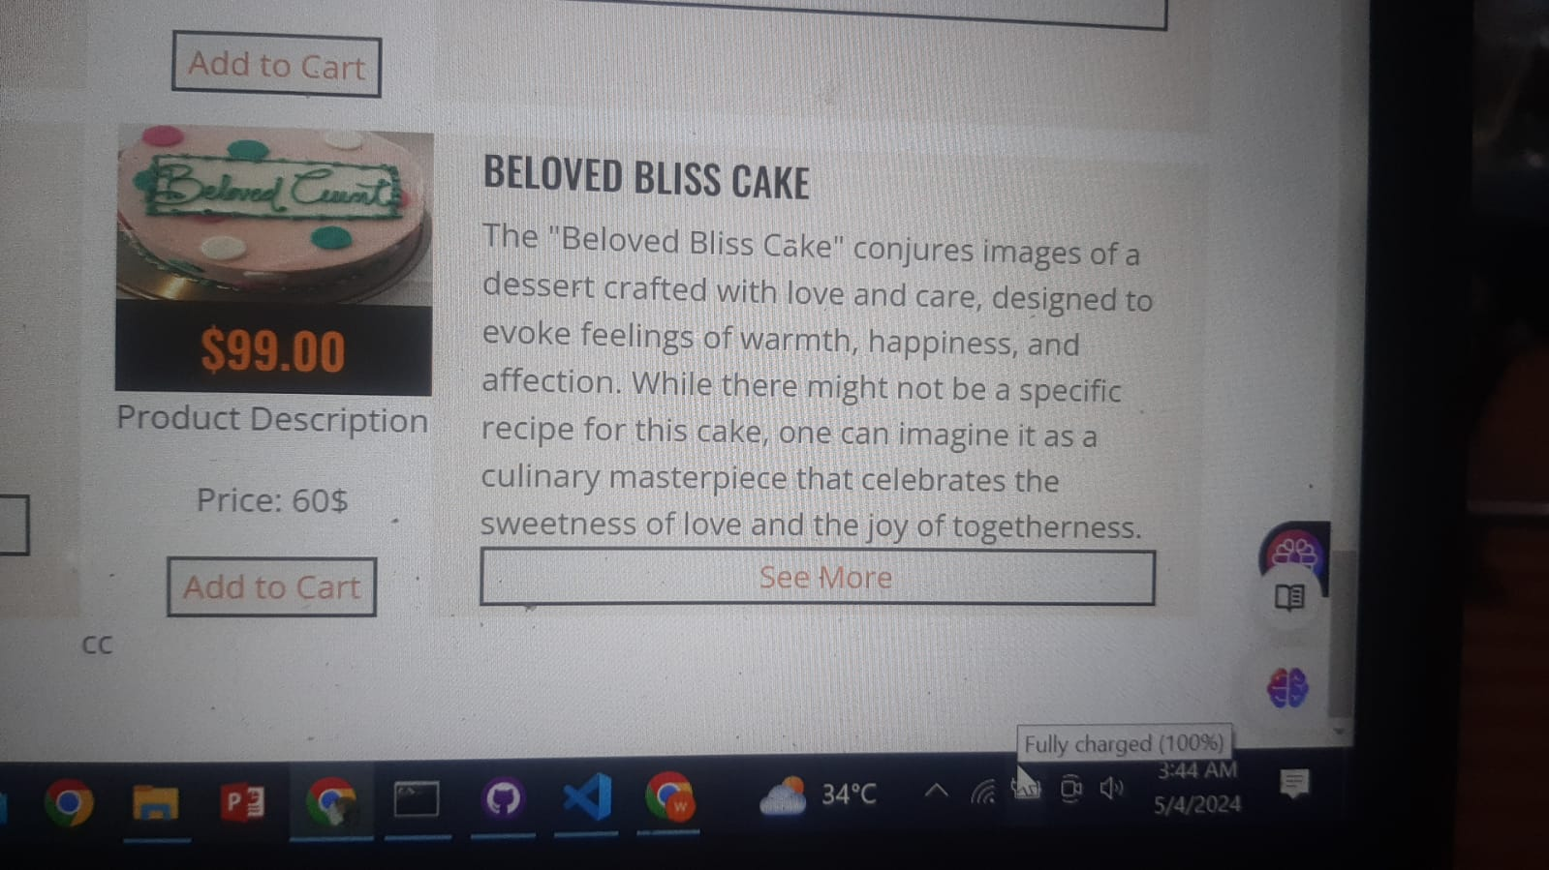

The Beloved Bliss Cake is a masterpiece of confectionary meant to arouse sentiments of coziness, warmth, and happiness. It is a culinary ode to indulgence and delight. Imagine a colossal structure, with layers piled high and proud, each slice offering a symphony of tastes. A silky layer of buttercream, smooth and opulent to the touch, covers the outside of the cake. Delicate swirls and flourishes adorn its surface, hinting at the decadence that lies within. As you delve into the Beloved Bliss Cake, you're greeted by layers of moist sponge cake, each infused with its own unique flavor. Rich chocolate, velvety vanilla, and delicate almond intertwine harmoniously, creating a symphony of taste that dances across your palate with every bite.However, the ingredients and toppings of the Beloved Bliss Cake are what really make it magical. Rich pockets of fruit compote, smooth custard, and silky ganache are hidden between each layer, each a revelation of taste and texture. Nestled between the layers are fresh berries, their tangy sweetness providing a refreshing vitality that cuts through the richness of the cake. When you get to the top of the cake, you'll find the pièce de résistance—a glossy chocolate ganache waterfall that cascades down the edges like velvet. It's a rich coda to an already exquisite meal, a finishing touch that turns the Beloved Bliss Cake from dessert into a veritable feast for the senses. Every taste of the Beloved Bliss Cake takes you to a another world.

**Product 17**

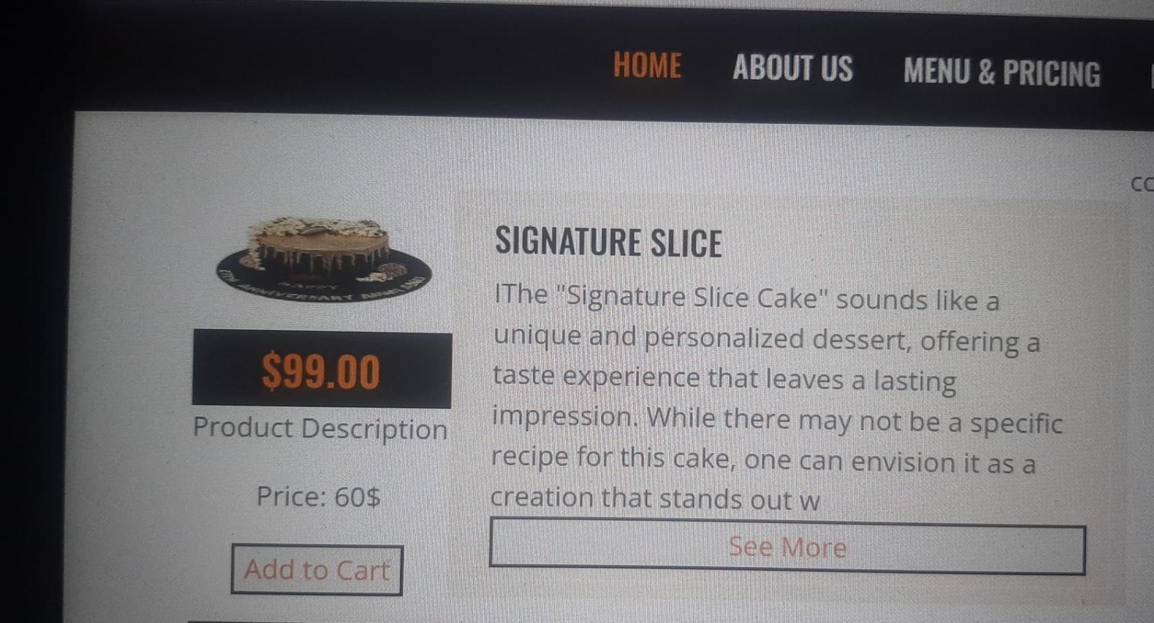

Cakes that perfectly capture the spirit and aesthetic of a specific bakery, pastry chef, or dessert artist are known as signature cakes. These cakes are more than simply sweets; they are artistic creations that highlight the imagination, talent, and inventiveness of their makers. This is an example of what could be on a signature cake: Distinctive Design: Distinguished from conventional cakes, signature cakes are distinguished by their distinctive and striking designs. Every distinctive cake, whether it's decorated with exquisite fondant creations, precise piping, or avant-garde presentations, is a visual beauty that makes an impression. Beyond their aesthetic appeal, trademark cakes frequently include artistic elements.Unforgettable Experience: Getting a signature cake is an experience in and of itself, even without the cake. Customers are treated to an unforgettable experience that results in a genuinely spectacular dessert that beyond their expectations, starting with the first consultation and design process and ending with the excitement of witnessing the finished masterpiece. In general, trademark cakes are artistic, imaginative, and passionate creations rather than just sweets. Signature cakes are made to make an impression and produce treasured memories for everyone who sees them, whether it's a wedding cake that depicts the romance of a couple's love story, a birthday cake that commemorates a significant occasion, or a show-stopping centerpiece for a special occasion.

**Product 18**

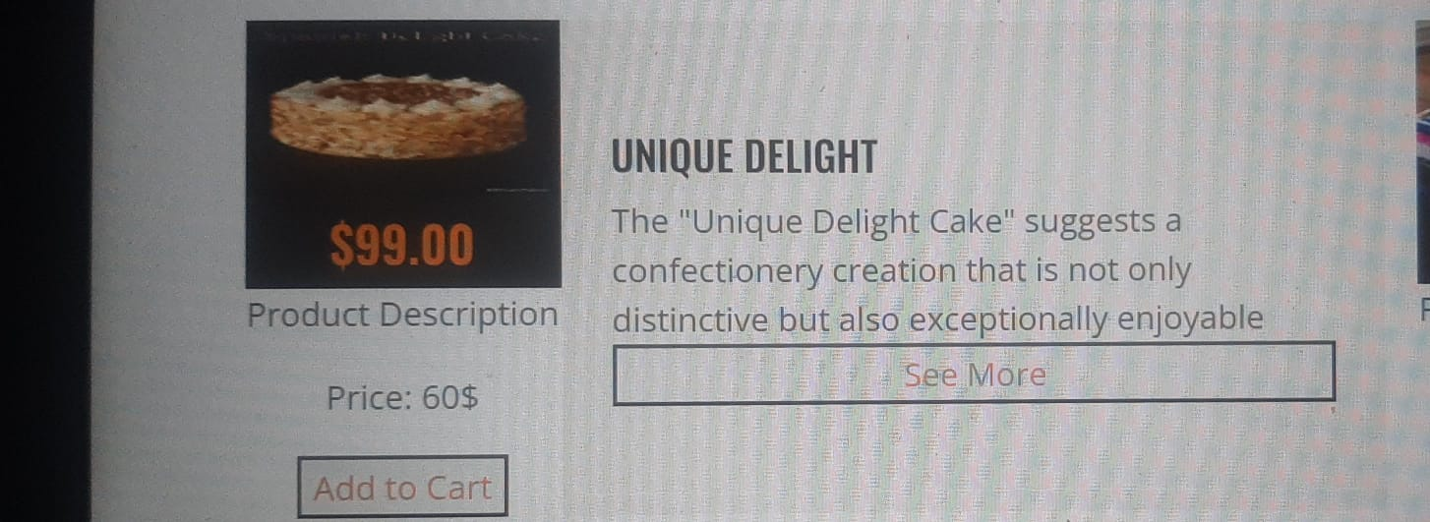

Extraordinary treats that push the limits of conventional cake design and flavor combinations are called unique pleasure cakes. These cakes are more than just treats; they are culinary works of art whose inventive ideas and surprising twists astonish and delight the senses.Every one of these one-of-a-kind pleasure cakes reflects the imagination and inventiveness of its maker. These cakes defy the conventions of traditional cake baking and take diners on a gastronomic adventure with their unique shapes, unusual ingredients, unexpected flavor combinations, and avant-garde presentations. This simple cake became a favourite at Australian bake sales, afternoon teas, and picnics as it swiftly acquired popularity. Its simplicity belies its irresistible appeal, with each bite offering a symphony of sweetness and texture. Over the years, variations have emerged, with some incorporating jam or cream fillings, while others experiment with different coatings or flavors. Despite these adaptations, the essence of the Lamington remains true to its roots—a beloved symbol of Australian culinary tradition and ingenuity.

**Product 19**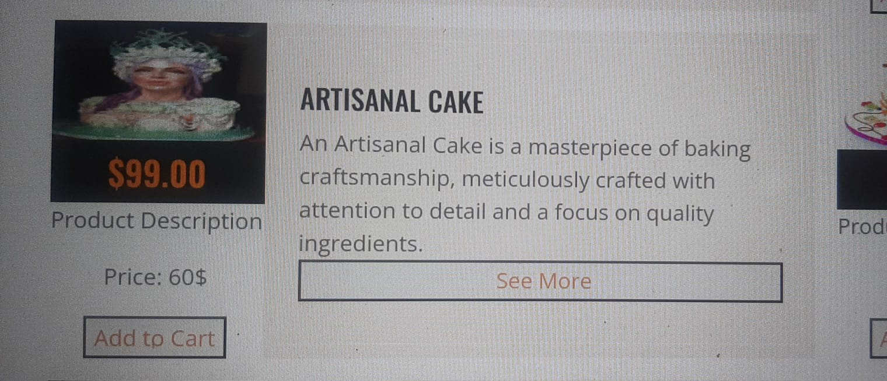

Artisanal cakes are exquisite confections crafted with meticulous attention to detail and a commitment to quality ingredients and craftsmanship. These cakes are not just desserts; they are culinary works of art that showcase the skill, creativity, and passion of the artisan behind them.

At their core, artisanal cakes are distinguished by their handmade nature and unique designs. Each cake is a reflection of the artisan's individual style and vision, featuring intricate decorations, handcrafted sugar flowers, and personalized touches that set it apart as a one-of-a-kind creation.

What sets artisanal cakes apart is their emphasis on quality ingredients and traditional baking techniques. From organic flour and free-range eggs to locally sourced fruits and premium chocolates, artisans use only the finest ingredients to ensure that every bite is a sublime experience.

In addition to their exquisite taste and craftsmanship, artisanal cakes often tell a story or evoke a particular theme or mood. Whether it's a whimsical fairy tale wedding cake, a vintage-inspired birthday creation, or a modern minimalist masterpiece, each cake is designed to captivate the imagination and create lasting memories for those who enjoy it.

**Product 20**

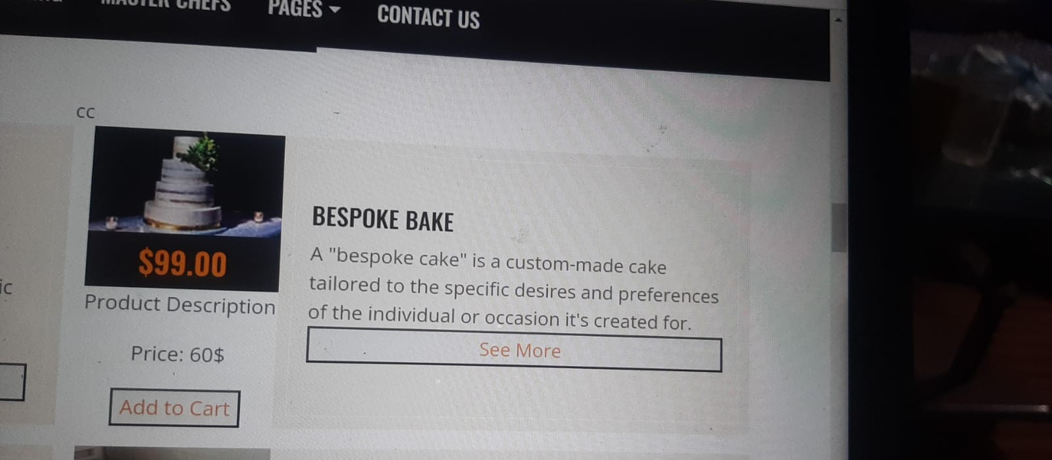

Bespoke cake custom cake is an extraordinary culinary creation that is painstakingly made to suit the specific preferences and needs of the person receiving it. A custom cake, in contrast to mass-produced sweets, is prepared specifically to capture the unique character and essence of the person for whom it is intended. Picture a blank canvas that is just ready to be decorated—a canvas that the baker's imagination can create anything on. The custom cake starts as a vision, a result of the baker and customer working together to turn ideas into tasty reality.From the intricate decorations to the sponge flavor, every component of the custom cake is thoughtfully chosen and assembled. Maybe it is a dense chocolate cake with layers of salted caramel and edible flowers. . Picture a blank canvas that is just ready to be decorated—a canvas that the baker's imagination can create anything on. The custom cake starts as a vision, a result of the baker and customer working together to turn ideas into tasty reality.Another possibility is that it's a fluffy vanilla sponge topped with a waterfall of buttercream roses and layers of tart lemon curd.

**Product 21**

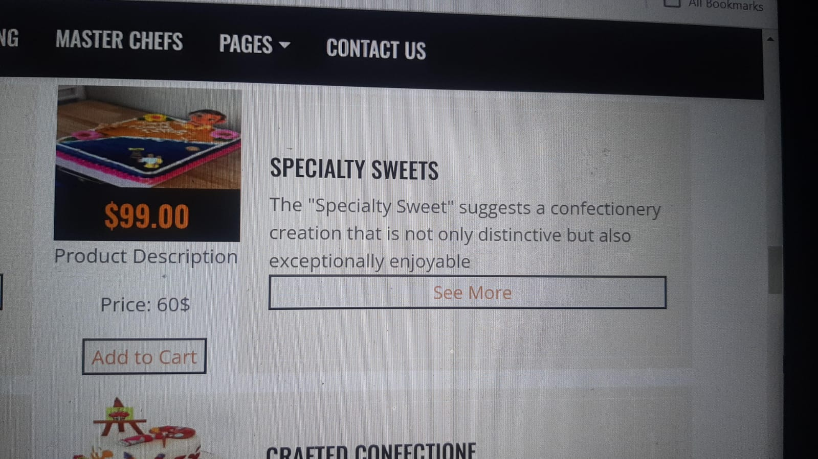

Specialty cakes are mouthwatering confections that are meant to excite the senses and take any occasion to new levels of decadence. These cakes are not your typical cakes; they have distinctive flavors, eye-catching designs, and individual touches that make them truly artistic creations.Every custom cake is expertly made, demonstrating the originality and talent of the pastry chef or baker who created it. Specialty cakes are available in a range of designs and themes to fit every taste and occasion, from sophisticated wedding cakes to imaginative birthday creations.Specialty cakes stand out for their meticulous attention to detail and dedication to excellence. Every component of a custom cake, whether it be the hand-piped embellishments, the detailed fondant sculptures, or the tiny sugar flowers, is expertly made.Another important element of specialty cakes is flavor. Although traditional tastes like chocolate and vanilla are constantly in style,. These surprising flavors give the cake a thrilling and intriguing quality that leaves a lasting impact on those who try it.

**Product 22**

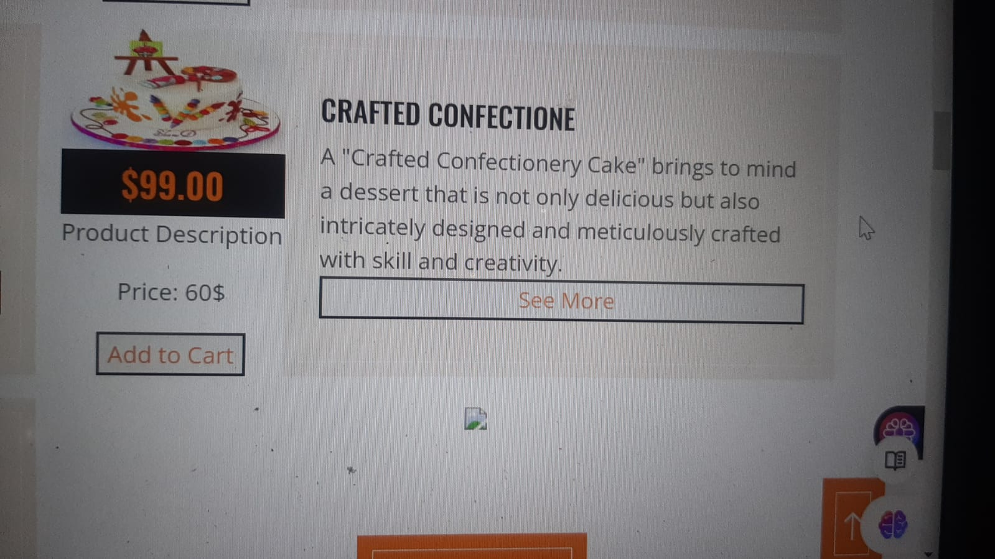

Crafted cake is a delicious treat that entices the senses with its distinct combination of flavours and textures. This classic cake, with its tiers of delectable sweet and savoury layers, is a masterwork of culinary craftsmanship. A well-crafted cake typically starts with a delicious, flavorful cake that has been baked to perfection with premium ingredients and exact quantities. Classic cake flavors like red velvet, chocolate, and vanilla are still well-liked, but more unusual tastes like matcha, lemon, and coconut are also gaining appeal.Cake decorations may truly be pieces of beauty! A well-made cake is genuinely exceptional, whether it's a towering wedding cake with elaborate fondant decorations, a quirky birthday cake with favorite figures, or a straightforward but exquisite cake with fine piping. are not only aesthetically pleasing but also delicious. Cakes range in taste from traditional chocolate and vanilla to more unusual selections like matcha or red velvet, so there's a cake for every occasion and palate. In addition, more people are experimenting with cake decorating as a way to express their creativity, thanks to the growth of custom cake businesses and online instructions. It's a delightful!

**Product 23**

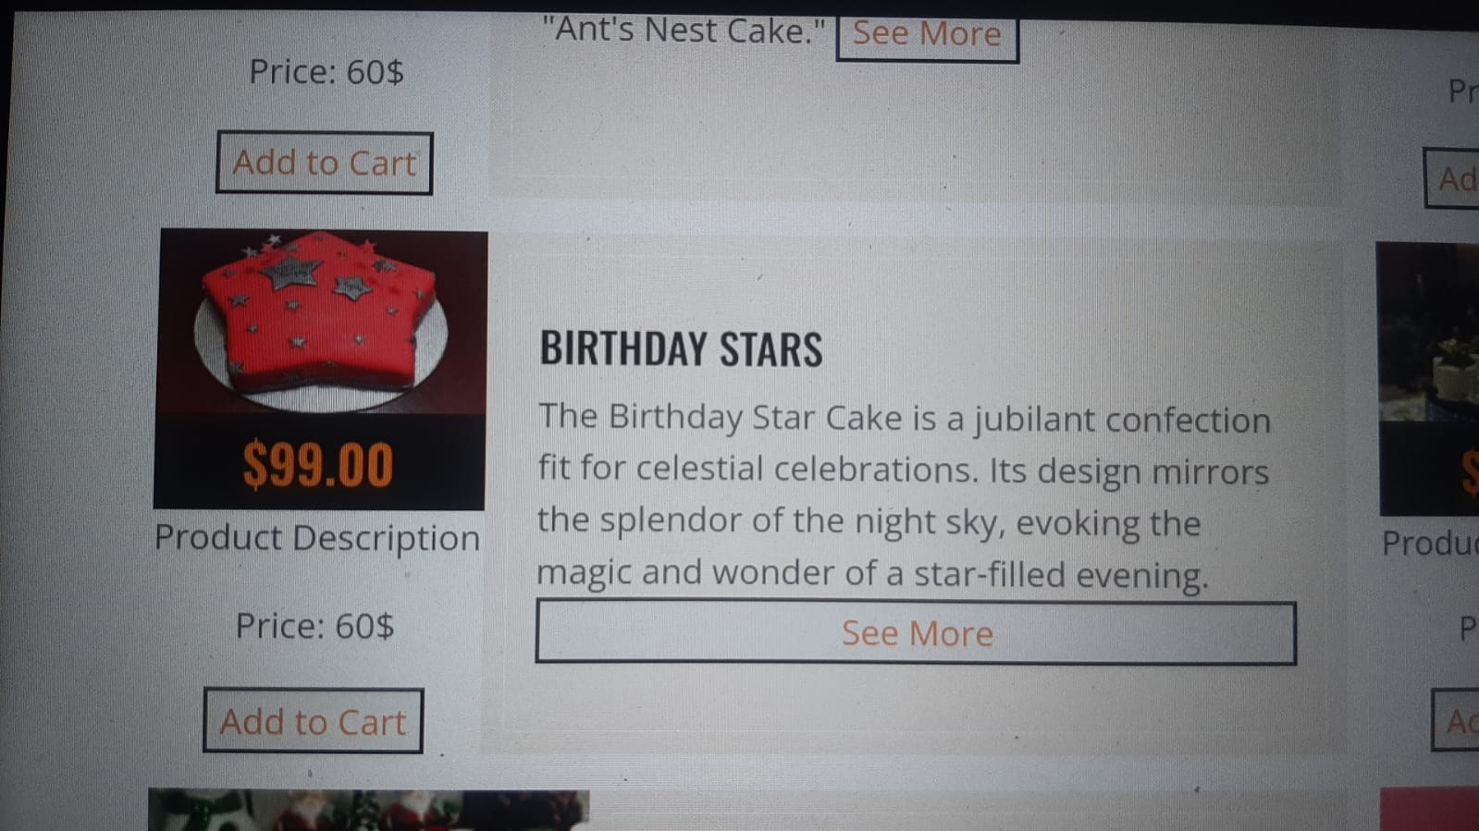

A delicious treat created to commemorate the special day of an exceptionally talented individual is the Birthday Star Cake. See a towering work of art, with every layer serving as a blank canvas for imagination and sweetness. The cake's sturdy base layer is usually a thick, moist layer that tastes like chocolate or vanilla. Moving above, you'll come across layers decorated with rich icing, possibly in colors that complement the celebration's celebratory theme. There may be hidden surprises between each layer, like as fluffy whipped cream, rich ganache, or fresh berries, giving each bite a taste and texture explosion.It is now time to discuss the aesthetics. The cake embodies the spirit of celebration and is a work of artistic adornment. Picture it covered in bright hues, maybe with fondant stars, glistening sprinkles, or edible glitter that twinkles like stars in the night sky. A stunning show awaits at the pinnacle of this edible artwork—possibly in the shape of a fondant figure or a personalized inscription proclaiming the recipient the day's real star.The Birthday Star Cake is essentially more than just a dessert; it's a work of art, lovingly created to make the birthday party genuinely remarkable.Let's now discuss the aesthetics. The cake is a work of artistic decorating that captures the spirit of the occasion. Imagine it covered in bright hues, maybe with stars made of fondant, sprinkles that shimmer, or edible glitter that glistens like stars in the night sky. The pinnacle of this edible artwork is a stunning presentation that can include a fondant figure or a personalized statement proclaiming the recipient to be the day's true star.Every bite has more depth thanks to the interaction of textures between these layers. Picture a layer of silky custard that melts into every slice, or a decadent fruit compote that is brimming with the flavor of perfectly ripe peaches or berries. The careful selection of each element ensures that the flavors and textures are harmoniously balanced with one another. Let's now discuss the decoration. Both the eyes and the palate will be treated to a visual feast with the Birthday Star Cake. Imagine elaborate patterns carefully piped onto the surface, maybe a starry sky with shooting stars slicing across a midnight-blue fondant sky. A whimsical touch is added to the ensemble by the colorful edible flowers that cascade down the edges.Not to be overlooked are the final details, the decorations that take this cake from delicious to spectacular. Maybe a dusting of edible gold dust, which catches the light and gives the whole thing a warm, golden sheen. Or perhaps it's decorated with exquisite sugar flowers, as if taken from a magical garden, each petal fashioned with care and accuracy. The Birthday Star Cake, created with passion and imagination to celebrate the dazzling star at the center of the celebration, is essentially more than simply a dessert. It is a work of culinary craftsmanship. The Birthday Star Cake is essentially more than just a dessert; it's a work of art, lovingly created to make the birthday party genuinely remarkable. There is a symphony of flavors waiting to be found as you cut through each layer. A layer could have undertones of caramel or espresso to entice the palate with a lovely richness. The exotic allure of tropical fruits like mango or passionfruit, or the tart sweetness of lemon, may reveal another dimension that catches you off guard. Every bite has more depth thanks to the interaction of textures between these layers. Picture a layer of silky custard that melts into every slice, or a decadent fruit compote that is brimming with the flavor of perfectly ripe peaches or berries. The careful selection of each element ensures that the flavors and textures are harmoniously balanced with one another.Let's now discuss the decoration. Both the eyes and the palate will be treated to a visual feast with the Birthday Star Cake. Imagine elaborate patterns carefully piped onto the surface, maybe a starry sky with shooting stars slicing across a midnight-blue fondant sky. A whimsical touch is added to the ensemble by the colorful edible flowers that cascade down the edges.

**Product 24**

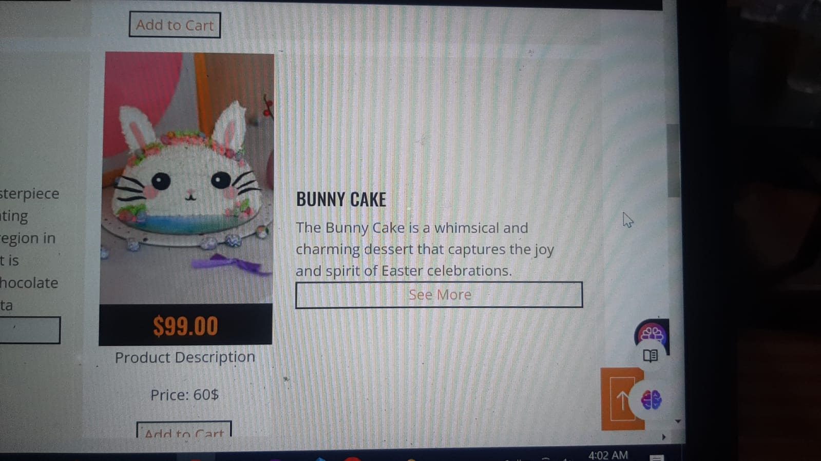

A cute and fun treat, rabbit cakes are ideal for Easter celebrations or any springtime get-together. Envision a cake fashioned like a cute rabbit, complete with fluffy frosting fur and endearing features that give it life. Layers of wonderful, moist cake, usually in flavors like chocolate or vanilla, form the base of a rabbit cake; but, because it's Easter, carrot cake is also a popular option. The form of a bunny is created by stacking and carving these layers, with one layer representing the body and another the head. Once the basic shape of a bunny has been achieved, a layer of smooth buttercream or cream cheese icing is applied to the cake to represent the fur of the bunny.Once the basic shape of a bunny has been achieved, a layer of smooth buttercream or cream cheese icing is applied to the cake to represent the fur of the bunny. To capture the essence of spring, you can dye the frosting with gentle pastel hues like lavender, blue, or pale pink. Extra embellishments are put to the bunny cake to give it personality. These might be jelly beans or chocolates covered in candy for the eyes, a tiny pink icing triangle for the nose, and piped frosting or crushed coconut for the whiskers. To finish the look, put a set of floppy ears to the bunny's head using fondant, marshmallows, or even cardboard covered in icing. Fur Texture: The bunny cake's frosting has a texture that mimics the fluffy fur of a rabbit, rather than just being smooth. Imagine delicate icing in the shape of gentle peaks or swirls variety of ways to represent different emotions. Imagine the bunny having long, floppy ears that hang down to the side, lending it a carefree, easygoing attitude. An alternative would be for the ears to stand straight, suggesting attention and inquiry. The bunny's overall appearance and charm are enhanced by the careful shaping and placement of each ear.

**Product 25**

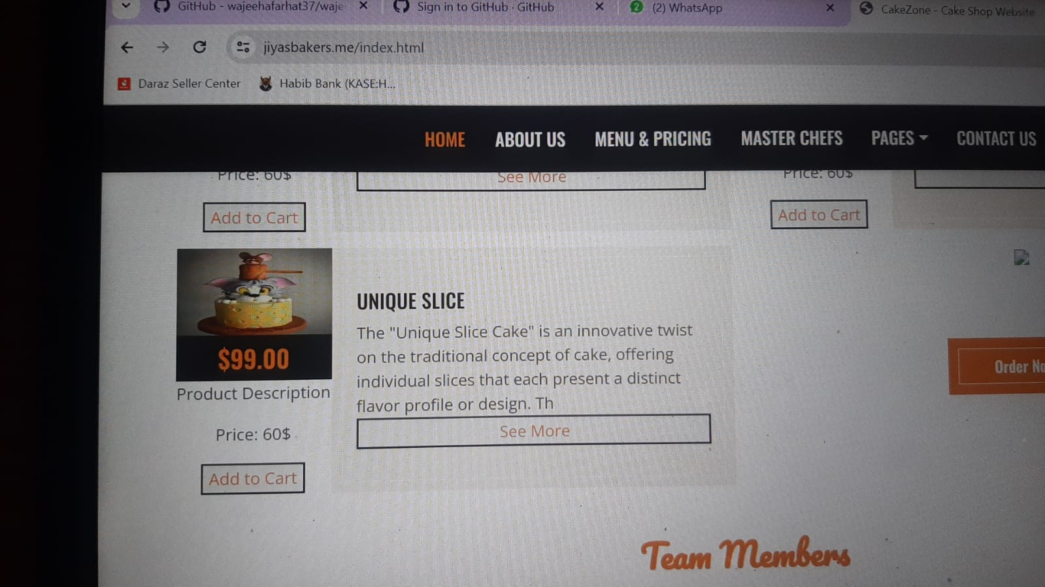

Unique special slice cakes are a fascinating take on classic cakes, providing bite-sized pieces that are both aesthetically pleasing and delicious. By deviating from the conventional whole-cake arrangement, these cakes let each visitor have their own customized piece of decadence. The inventive way that these slice cakes are presented is what sets them apart. Rather of taking on the conventional round or rectangular form, these cakes are frequently decorated with striking and original patterns that turn each piece into a work of art. Every slice is a visual treat, with designs ranging from simple shapes like hearts or stars to more complex patterns influenced by nature or abstract art.ralian bake sales, afternoon teas, and picnics as it swiftly acquired popularity. Its simplicity belies its irresistible appeal, with each bite offering a symphony of sweetness and texture. Over the years, variations have emerged, with some incorporating jam or cream fillings, while others experiment with different coatings or flavors. Despite these adaptations, the essence of the Lamington remains true to its roots—a beloved symbol of Australian culinary tradition and ingenuity. Apart from their imaginative forms, distinctive slice cakes frequently showcase inventive blending of flavors and luscious fillings. Layers of moist cake flavored with matcha green tea, raspberry lemon, or salted caramel may be found in each slice, while rich fillings like fluffy mousse, silky ganache, or tart fruit curd may accompany the layers. The variety of unique slice cakes is what makes them so beautiful. These individual portions provide visitors the freedom to savor a range of flavors and patterns, whether they are served at weddings, birthday celebrations, or other special occasions. Furthermore, they don't need to be sliced or plated because of their handy size, which makes them ideal for effortless serving and enjoyment

**Tools and technology Used:**

* VS code
* Google
* Youtube
* Picfree
* Jawascript
* Html/css

**Refrences**

* <link href="img/favicon.ico" rel="icon">
* <link rel="preconnect" href="https://fonts.googleapis.com">
* <link rel="preconnect" href="https://fonts.gstatic.com" crossorigin>
* <linkhref="https://fonts.googleapis.com/css2?family=Open+Sans:wght@400;600&family=Oswald:wght@5

**Github link**

[**https://github.com/wajeehafarhat37/wajeehafarhat37.github.io**](https://github.com/wajeehafarhat37/wajeehafarhat37.github.io)

**And My website link**

<https://jiyasbakers.me/>

**Sitemap.xml**

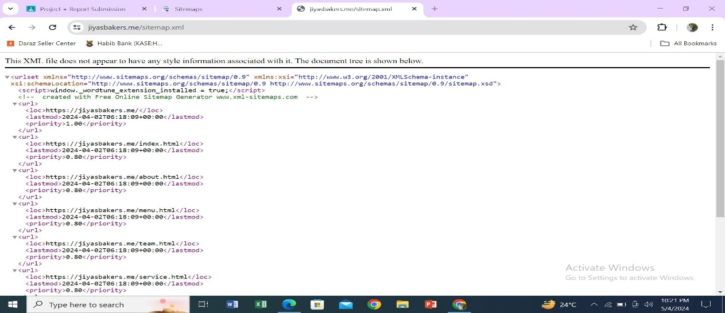

**Google Console Analytic**